 | SOLAR POWER PREDICTOR  – A MACHINE LEARNING BASED SOLAR POWER GENERATION PREDICTION SYSTEM WITH A WEB-BASED INTERFACE | 

A MINI PROJECT REPORT
Submitted by
RAJALAKSHMI.S | [Register No: 723724106084]
POOJA.R | [Register No: 723724106082]
VIDHULA.A | [Register No: 723724106120]

In partial fulfillment for the award of the degree of
BACHELOR OF ENGINEERING
IN
DEPARTMENT OF ELECTRONICS AND COMMUNICATION ENGINEERING

V.S.B COLLEGE OF ENGINEERING TECHNICAL CAMPUS
(An Autonomous Institution)
COIMBATORE-642109, TAMIL NADU.

ANNA UNIVERSITY: CHENNAI 600 025
NOVEMBER – 2026

BONAFIDE CERTIFICATE
Certified that this mini project report “Solar Power Generation Prediction Using Machine Learning and a Web-Based Interface” is the bonafide work of the following student(s), RAJALAKSHMI.S [Register No: 723724106084] ,POOJA.R [Register No:723724106082], VIDHULA.A [Register No:723724106120] who carried out the project work under my supervision.

SIGNATURE | SIGNATURE
Mrs. N.GEETHA PRIYA, HEAD OF THE DEPARTMENT, | Dr.T.SIVAPRAKASAM, SUPERVISOR,
Department of Electronics and Communication Engineering, V.S.B College of Engineering Technical Campus, Coimbatore-642109 | Department of Electronics and Communication Engineering, V.S.B College of Engineering Technical Campus, Coimbatore-642109

Submitted for the project viva-voce held on ...................................

INTERNAL EXAMINER | EXTERNAL EXAMINER

ACKNOWLEDGEMENT
First of all we extend our heartfelt gratitude to the management of V.S.B College of Engineering Technical Campus institutions, Chairman Mr. V. S. BALSAMY B.Sc., L.L.B., for providing us with all sort of support in the completion of this project.
We record our indebtedness to our Principal Dr. V. VELMURUGAN for his guidance and sustained encouragement for the successful completion of the project.
We also record our indebtedness to our Vice Principal Dr. POORNACHANDRAN for his guidance and sustained encouragement for the successful completion of the project.
We are highly grateful to Mrs.N. GEETHA PRIYA, Head of the Department, Department of Electronics and Communication Engineering for her valuable suggestions throughout the course of this project.
We owe our gratitude to our project coordinator [coordinator name] for the encouragement and timely support and guidance till the completion of the project work.
We also extend our sincere thanks to our project guide Dr.T.SIVAPRAKASAM for the kind support, unfailing encouragement and timely assistance, which led us to the successful completion of our project work.
We extend our heartfelt salutation to our beloved parents and friends, who have always been an integral part in helping us through tough times, and to all teaching and non-teaching staff for providing their moral support in making this project a success.



VISION AND MISSION STATEMENTS OF THE INSTITUTE

Vision:
We endeavor to impart futuristic technical education of the highest quality in the student community to inculcate discipline in them to face the world with self-confidence and thus we prepare them for life as responsible citizens to uphold human values and to be of service at large. We strive to bring up the Institution as an Institution of Academic excellence of International standard.

Mission:
We transform persons into personalities by the state-of-the-art infrastructure, time consciousness, quick response and the best academic practices through assessment and advice.

VISION AND MISSION STATEMENTS OF THE DEPARTMENT
Name of the Department: Department of Electronics and Communication Engineering

Vision:
To become a forerunner in producing skilled graduates with strong foundation in Electronics and Communication Engineering who can contribute significantly to the society.

Mission:
- To provide excellent infrastructure and enriched curriculum to train and develop highly competent engineers with research aptitude.
- To foster the skills of employability and entrepreneurship along with social responsibility among the students transforming them into intellectual professionals to support nation's growth.
- To motivate the students in gaining knowledge about the modern technologies to meet the dynamic industrial needs supporting lifelong learning.

PEO, PO AND PSO STATEMENTS

Program Educational Objectives (PEO):
PEO1 – Graduates will have sound knowledge in the core areas of Electronics, Communication and allied Engineering to analyze and propose solutions for day-to-day engineering problems facing the society.
PEO2 – Graduates will have necessary skills to do research and work as an entrepreneur with self-confidence in interdisciplinary fields of Engineering.
PEO3 – Graduates will have managerial and interpersonal skills to work as an individual and as a team with continuous learning to boost their organization's growth.
PEO4 – Graduates will have self-discipline, ethical values and social responsibility setting a good role model for future generations.

Program Outcomes (POs):
- Engineering knowledge: Apply the knowledge of mathematics, science, engineering fundamentals and an engineering specialization to the solution of complex engineering problems.
- Problem analysis: Identify, formulate, review research literature, and analyze complex engineering problems reaching substantiated conclusions using first principles of mathematics, natural sciences, and engineering sciences.
- Design/development of solutions: Design solutions for complex engineering problems and design the system components or processes that meet the specified needs with appropriate consideration for public health and safety, and the cultural, societal, and environmental considerations.
- Conduct investigations of complex problems: Use research-based knowledge and research methods including design of experiments, analysis and interpretation of data, and synthesis of the information to provide valid conclusions.
- Modern tool usage: Create, select, and apply appropriate techniques, resources, and modern engineering and IT tools including prediction and modeling to complex engineering activities with an understanding of the limitations.
- The engineer and society: Apply reasoning informed by the contextual knowledge to assess societal, health, safety, legal and cultural issues and the consequent responsibilities relevant to the professional engineering practice.
- Environment and sustainability: Understand the impact of the professional engineering solutions in societal and environmental contexts, and demonstrate the knowledge of, and need for sustainable development.
- Ethics: Apply ethical principles and commit to professional ethics and responsibilities and norms of the engineering practice.
- Individual and team work: Function effectively as an individual, and as a member or leader in diverse teams, and in multidisciplinary settings.
- Communication: Communicate effectively on complex engineering activities with the engineering community and with society at large, such as, being able to comprehend and write effective reports and design documentation, make effective presentations, and give and receive clear instructions.
- Project management and finance: Demonstrate knowledge and understanding of the engineering and management principles and apply these to one's own work, as a member and leader in a team, to manage projects and in multidisciplinary environments.
- Life Long Learning: Recognize the need for, and have the preparation and ability to engage in independent and life-long learning in the broadest context of technological change.

Program Specific Outcomes (PSOs):
PSO1 – Students will be trained in the field of electronics systems, designs and develop solutions enhancing their employability and entrepreneurship skills.
PSO2 – Students will be inspired to develop analytical, domain and soft skills which will enable them to crack national level competitive examinations for higher studies and employment.

RELEVANCE TO PO'S AND PSO'S:
DESCRIPTION | PO'S MAPPING | PSO'S MAPPING
Application of machine learning regression models to predict solar power output | PO1, PO2, PO5 | PSO1
Data cleaning, feature engineering and evaluation using RMSE, MAE and R² | PO3, PO4 | PSO1, PSO2
Deployment of the best model as a web application | PO5, PO11 | PSO2
Supporting renewable energy, grid planning and sustainability | PO6, PO7, PO12 | PSO1, PSO2
Ethics, documentation, presentation and project management | PO8, PO9, PO10 | PSO2

TABLE OF CONTENTS
SL.NO | TITLE | PAGE NO
1 | ABSTRACT | 9
2 | LIST OF FIGURES | 10
 | LIST OF TABLES | 11
 | LIST OF ABBREVIATIONS | 12
3 | CHAPTER 1 | 13
 | 1.1 INTRODUCTION | 13
 | 1.2 DATASET AND FEATURES | 13
 | 1.3 MACHINE LEARNING MODELS | 14
 | 1.4 WEB APPLICATION | 14
 | 1.5 OBJECTIVES OF THE PROJECT | 14
 | 1.6 SCOPE OF THE PROJECT | 15
 | 1.7 ORGANIZATION OF THE REPORT | 15
4 | CHAPTER 2 | 16
 | 2.1 LITERATURE SURVEY | 16
5 | CHAPTER 3 | 18
 | 3.1 EXISTING METHODOLOGY | 18
 | 3.2 PROPOSED METHODOLOGY | 18
 | 3.3 BLOCK DIAGRAM | 19
 | 3.4 FUNCTIONAL MODULES | 21
 | 3.5 DATA FLOW AND WORKFLOWS | 22
 | 3.6 DATASET DESIGN | 24
 | 3.7 WEB INTERFACE AND FUNCTION DESIGN | 25
 | 3.8 RELIABILITY AND VALIDATION DESIGN | 25
 | 3.9 WORKING OF THE SYSTEM | 26
 | 3.10 ALGORITHMS | 26
 | 3.11 COMPARISON OF EXISTING AND PROPOSED SYSTEMS | 27
6 | CHAPTER 4 | 28
 | 4.1 SOFTWARE DESCRIPTION | 28
 | 4.2 MACHINE LEARNING MODELS | 28
 | 4.3 RESULTS AND DISCUSSION | 30
 | 4.4 TESTING | 33
 | 4.5 DISCUSSION | 34
 | 4.6 SAMPLE INPUTS AND OUTPUTS | 34
 | 4.7 COST AND ACCESSIBILITY ANALYSIS | 34
 | 4.8 APPLICATIONS | 35
 | 4.9 CHALLENGES FACED | 35
7 | CHAPTER 5 | 36
 | 5.1 CONCLUSION | 36
8 | APPENDIX | 38
9 | REFERENCES | 40

ABSTRACT
Solar power output varies throughout the day with irradiation, ambient temperature and module temperature, which makes it hard for grid operators to balance supply and demand. Traditional planning methods that assume steady generation, or that rely on manual estimation, cannot follow these changes in real time. To address this issue, this project presents a machine learning system that predicts the DC power output of a solar plant from weather sensor data and time features, and makes the prediction available through a simple web page.
Plant generation data and weather sensor data, both recorded at 15-minute intervals, are merged by timestamp and cleaned. Hour of day and month are added as features. Three regression models are compared: Linear Regression as a baseline, Random Forest and Gradient Boosting. The data is split chronologically, with the first 80% used for training and the last 20% for testing. Models are evaluated using Root Mean Square Error (RMSE), Mean Absolute Error (MAE) and the coefficient of determination (R²). [Best model] achieved an R² of [value] and an RMSE of [value] kW on the test set.
The system is built in Python using Pandas, NumPy, scikit-learn and Matplotlib, and the best model is deployed as a web application in which a user enters weather values and receives a predicted power output in kW. Unlike manual estimation, the proposed solution gives fast, repeatable predictions, does not depend on costly hardware, and is available to non-expert users through a free, hosted web page.

LIST OF FIGURES
FIGURE NO | TITLE | PAGE NO
3.1 | System Architecture (Block Diagram) | 21
3.2 | Technology Stack of the System | 21
3.3 | Functional Modules of the System | 22
3.4 | Use Case Diagram | 23
3.5 | Data Flow Diagram | 24
3.6 | Sequence Diagram of a Prediction Request | 24
3.7 | Machine Learning Model Development Pipeline | 25
3.8 | Web Application Workflow | 25
3.9 | Time-Based Train–Test Split | 27
3.10 | Layered Reliability Design | 27
4.1 | Daily Solar Power Curve | 29
4.2 | Model Performance Comparison (RMSE, MAE, R²) | 29
4.3 | Actual vs Predicted DC Power | 31
4.4 | Random Forest Feature Importance | 35

LIST OF TABLES
TABLE NO | TITLE | PAGE NO
2.1 | Summary of reviewed work | 16
2.2 | Groups of solar forecasting approaches | 17
3.1 | Dataset fields | 24
3.2 | Web interface elements | 25
3.3 | Main functions of the code | 25
3.4 | Existing versus proposed methodology | 27
4.1 | Software and hardware requirements | 28
4.2 | Model hyperparameters | 29
4.3 | Qualitative comparison of the models | 30
4.4 | Performance comparison of models on the test set | 31
4.5 | Testing summary | 33
4.6 | Sample prediction outputs | 34
4.7 | Comparison of forecasting approaches | 34

LIST OF ABBREVIATIONS
Abbreviation | Expansion
AI | Artificial Intelligence
ML | Machine Learning
PV | Photovoltaic
DC | Direct Current
RMSE | Root Mean Square Error
MAE | Mean Absolute Error
R² | Coefficient of Determination
RF | Random Forest
GB | Gradient Boosting
LSTM | Long Short-Term Memory
CSV | Comma-Separated Values
API | Application Programming Interface
UI / UX | User Interface / User Experience
IoT | Internet of Things

CHAPTER 1
INTRODUCTION

1.1 INTRODUCTION
Solar energy is clean and renewable, and the number of solar plants connected to power grids continues to grow. However, photovoltaic (PV) output is not steady. It changes with cloud cover, temperature and time of day. Because electricity supply must match demand at all times, this variability makes grid planning difficult. Traditional methods such as fixed daily estimates and manual planning are not always effective, as they cannot follow rapid changes in weather.
In response to these challenges, data-driven forecasting has emerged as a practical way to estimate solar output from available weather readings. However, many existing approaches need detailed plant physics, ignore weather variables, or are not easily usable by people without a programming background.
This project proposes a machine learning system built in Python that uses plant generation data and weather sensor data to predict DC power output. Accurate prediction of solar output supports three practical goals: balancing the grid, planning when to charge or use energy storage, and reducing the cost of backup power and wasted energy. The system is fully software-based and is delivered through a Streamlit web page.

1.1.1 Problem Statement
A solar plant does not deliver the same power throughout the day or across the seasons. Operators and planners need to know in advance, or at least quickly, how much DC power the plant will produce under given weather conditions. Manual estimates are slow and inaccurate, and physical models need data that is rarely available. The problem addressed in this project is to build a simple, accurate and easily accessible tool that predicts the DC power output of a solar plant from weather and time inputs.

1.1.2 Motivation
The growth of renewable energy has made solar forecasting an important part of modern grid operation. At the same time, machine learning libraries and free hosting services have made it possible for a student project to deliver a complete, working prediction tool at almost no cost. This project is motivated by the need to show that a clear, well-evaluated pipeline, from raw CSV files to a public web page, can support better planning of solar energy use.

1.2 DATASET AND FEATURES
The study uses the Solar Power Generation Data available on Kaggle [6]. It has two parts: plant generation data (power output of the plant) and weather sensor data recorded at the plant. Both are sampled every 15 minutes and provided as two CSV files, which are merged using their timestamps.
Input features:
- Irradiation: the solar energy reaching the panels; expected to be the strongest predictor of power.
- Ambient temperature: the air temperature around the plant.
- Module temperature: the temperature of the solar panels, which affects conversion efficiency.
- Hour of day: derived from the timestamp.
- Month: derived from the timestamp.

1.2.1 Role of Each Feature
Irradiation drives the current produced by the panels, so power rises almost in proportion to it. Module temperature affects efficiency: hotter panels convert sunlight less efficiently, which lowers the output for the same irradiation. Ambient temperature is related to module temperature and to the weather of the day. Hour of day describes the position of the sun and gives the bell-shaped daily curve, while month describes the season and the length of the day. Together, these five inputs describe both the instant weather and the time context, and they are all easy to obtain.
Target: DC power output in kW. After merging, rows with missing values are removed. The final dataset contains [number] samples covering [date range].

1.3 MACHINE LEARNING MODELS
Linear Regression is used as a simple baseline. It fits a straight-line relationship between the input features and power output. Random Forest [3] builds many decision trees on random subsets of the data and features and averages their predictions; it handles non-linear patterns well. Gradient Boosting [4] builds trees one after another, where each new tree is trained to correct the errors of the previous ones.

1.4 WEB APPLICATION
The best-performing model is saved and used in a web application built with Streamlit [8]. The user enters weather values, clicks Predict, and the predicted power output is displayed in kW. The application is hosted free online so that anyone can use it without installing software.

1.5 OBJECTIVES OF THE PROJECT
- To collect, merge and clean solar generation and weather data.
- To create time-based features that capture the daily and seasonal pattern of solar output.
- To train and compare Linear Regression, Random Forest and Gradient Boosting models.
- To evaluate the models objectively using RMSE, MAE and R² on unseen, later data.
- To predict solar power output accurately from weather and time inputs.
- To build a web page that anyone can use without programming knowledge.

1.6 SCOPE OF THE PROJECT
The project is intended for students, plant operators and planners who need quick estimates of solar output. It covers data preparation, model training and comparison, evaluation using standard metrics and deployment of the best model as a web application. The system can be extended in the future with weather forecast APIs for next-day prediction, deep learning models such as LSTM, and data from more plants and locations.

1.7 ORGANIZATION OF THE REPORT
Chapter 1 introduces the problem of solar variability, the dataset and models, and the objectives and scope of the project. Chapter 2 reviews the related literature and identifies the research gap. Chapter 3 describes the existing and proposed methodologies together with the block diagram, functional modules, data flow, dataset design, interface design and algorithms. Chapter 4 explains the software tools, the machine learning models, and the results, testing and discussion. Chapter 5 concludes the report and lists the future scope, followed by the appendix and references.

CHAPTER 2
LITERATURE SURVEY

2.1 LITERATURE SURVEY
R. Ahmed, V. Sreeram, Y. Mishra and M. D. Arif [1] presented a review and evaluation of the state of the art in PV solar power forecasting, covering forecasting techniques and their optimization. PV forecasting methods are commonly grouped into physical models, statistical time-series models and machine learning models.
J. Antonanzas et al. [2] reviewed photovoltaic power forecasting methods, comparing the approaches used and the forecast horizons they suit. This review established solar forecasting as an active research area and guides the choice of methods in this project.
L. Breiman [3] introduced Random Forests, an ensemble method that averages many decision trees built on random subsets of the data and features. It is widely used for tabular regression because it captures non-linear relationships and needs little feature scaling.
J. H. Friedman [4] proposed the gradient boosting machine, in which trees are added one after another and each new tree corrects the errors of the earlier ones. It is a strong method for tabular prediction problems.
S. Hochreiter and J. Schmidhuber [5] introduced Long Short-Term Memory (LSTM) networks, which are used for sequence forecasting. LSTM models are a natural extension of this work.
[Add 3–5 more papers from your literature survey here, in the same style, and add them to the reference list.]

Summary of Literature
Table 2.1 Summary of reviewed work
Author / Work | Technique | Main finding | Limitation
Ahmed et al. [1] | Review of PV forecasting | Groups methods into physical, statistical and ML | Review only; no implementation
Antonanzas et al. [2] | Review of PV forecasting | Compares methods and forecast horizons | Does not give a ready-to-use tool
Breiman [3] | Random Forest | Strong for non-linear tabular regression | Not specific to solar data
Friedman [4] | Gradient Boosting | Sequential error correction improves accuracy | Needs careful tuning
Hochreiter & Schmidhuber [5] | LSTM | Models sequences over time | Needs more data and compute

Approaches Used in Solar Power Forecasting
The reviewed work shows that PV forecasting approaches can be placed in four broad groups. Table 2.2 summarises the basis, strength and limitation of each group, and shows where the models used in this project fit.
Table 2.2 Groups of solar forecasting approaches
Approach | Basis | Strength | Limitation
Physical models | Equations of the panels, site and atmosphere | Meaningful without large datasets | Needs detailed plant data and tuning
Statistical time-series | Past output values | Simple and quick | Ignores weather variables
Machine learning (this project) | Weather and time features learned from data | Captures non-linear patterns; no plant physics | Depends on data quality and coverage
Deep learning (LSTM) | Sequences of past data | Models time dependence | Needs more data and computing power
This project uses the machine learning group because it gives a good balance between accuracy, simplicity and ease of deployment for a software-only mini project.

Identified Research Gap
From the reviewed literature it is evident that many studies concentrate on forecasting methods or on model accuracy alone. Few provide a simple, low-cost pipeline that compares standard regression models with a time-based split and then delivers the best model through a web page that non-expert users can operate. This gap motivates the development of the proposed solar power prediction system.

CHAPTER 3
PROJECT DESCRIPTION

3.1 EXISTING METHODOLOGY

3.1.1 Variability of Solar Output
In the current situation, solar output changes with cloud cover, temperature and time of day. Without a prediction mechanism, grid operators cannot know in advance how much power a plant will deliver, which makes balancing supply and demand difficult.

3.1.2 Physical Models
Physical models describe the plant using detailed equations of the panels, the site and the atmosphere. They need detailed plant information and careful tuning, which is often not available.

3.1.3 Statistical Time-Series Models
Statistical models predict future output from past output alone. They do not use weather variables directly and can struggle when conditions change quickly.

3.1.4 Reliance on Manual Estimation
Fixed daily estimates and manual planning are still used in many places. They cannot follow cloudy periods, sunrise and sunset changes or seasonal variation, and they depend on the planner's experience.

3.1.5 DISADVANTAGE
Existing approaches either need detailed plant physics, ignore weather inputs, or depend on manual effort. As a result, predictions are less accurate, slower to produce and not easily available to non-expert users. Machine learning methods also have limits: their accuracy depends on the quality and coverage of the training data, and a model trained on one plant may not generalize to another.

3.2 PROPOSED METHODOLOGY

3.2.1 Introduction of a Machine Learning Based Prediction System
The proposed methodology introduces a complete, working pipeline that covers data preparation, comparison of several regression models, and a simple web interface. Machine learning methods learn the relationship between weather variables and generated power directly from data and do not need detailed plant physics.

3.2.2 Problem Analysis and Requirement Gathering
The development started with a study of how solar variability affects grid planning and storage scheduling. Existing forecasting approaches were reviewed to identify their limitations. Functional and non-functional requirements such as accuracy, speed, ease of use and free access were then defined.

3.2.3 Data Collection and Cleaning
The plant generation file and the weather sensor file, both sampled every 15 minutes, are loaded and merged using their timestamps. Rows with missing values are removed so that the models are trained on complete records.
Night-time records, where irradiation and power are both zero, are kept in the dataset because they are a genuine part of the daily solar pattern and the web application must also return a sensible output for them. Only rows with missing values are removed.

3.2.4 Feature Engineering
Hour of day and month are derived from the timestamp and added to irradiation, ambient temperature and module temperature. These time features help the model learn the daily and seasonal pattern of solar output.

3.2.5 Model Training and Comparison
Three models are trained: Linear Regression (baseline), Random Forest and Gradient Boosting. All are implemented in Python using scikit-learn [7]. The hyperparameters used are listed in Table 4.2.

3.2.6 Time-Based Train–Test Split
The data is split by time rather than at random. The first 80% of the records are used for training and the last 20% for testing. This means the model is tested on later data that it has not seen, which is closer to real forecasting use and avoids leaking future information into training.

3.2.7 Web Interface Development
The best model is saved and loaded by a Streamlit web application. A user enters weather values and receives a predicted power output in kW, so no programming knowledge is needed.

3.2.8 ADVANTAGE
The proposed system offers fast and repeatable predictions without manual effort. It uses weather and time features that are easy to obtain, compares several models objectively using standard metrics, and avoids information leakage through a time-based split. The Streamlit page is user-friendly and hosted free online, so anyone can use it without installing software. The pipeline can be extended with forecast data and deep learning models, and it supports grid balancing, storage scheduling and plant monitoring.

3.3 BLOCK DIAGRAM
The Solar Power Prediction System follows a simple layered architecture comprising a data layer, a machine learning layer and a web application layer. The overall block diagram is shown in Fig 3.1.
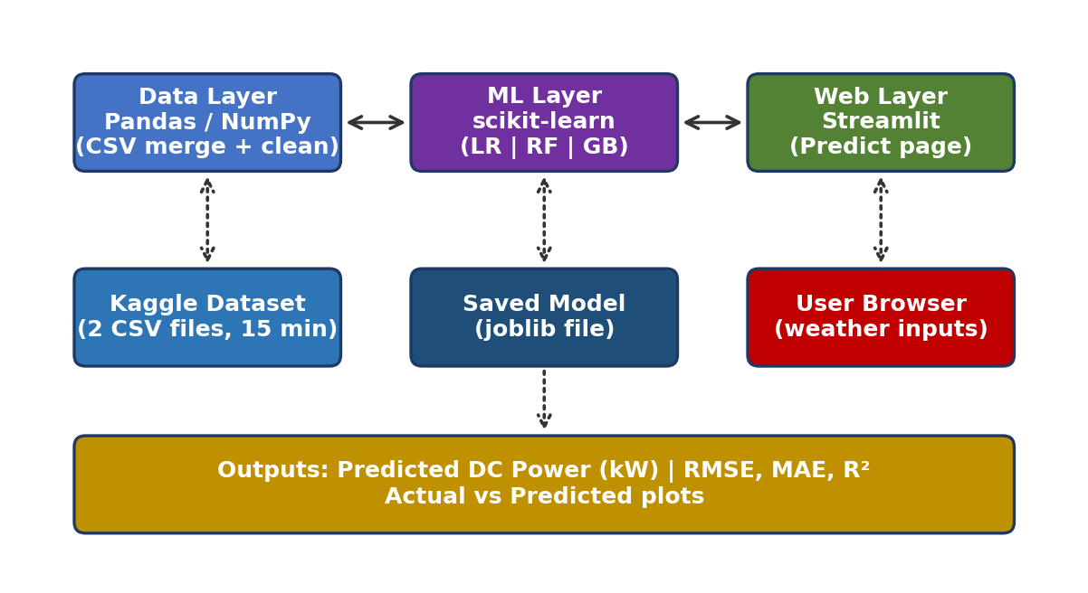
Fig 3.1 System Architecture (Block Diagram)
The technology stack used in each layer of the system is summarised in Fig 3.2.
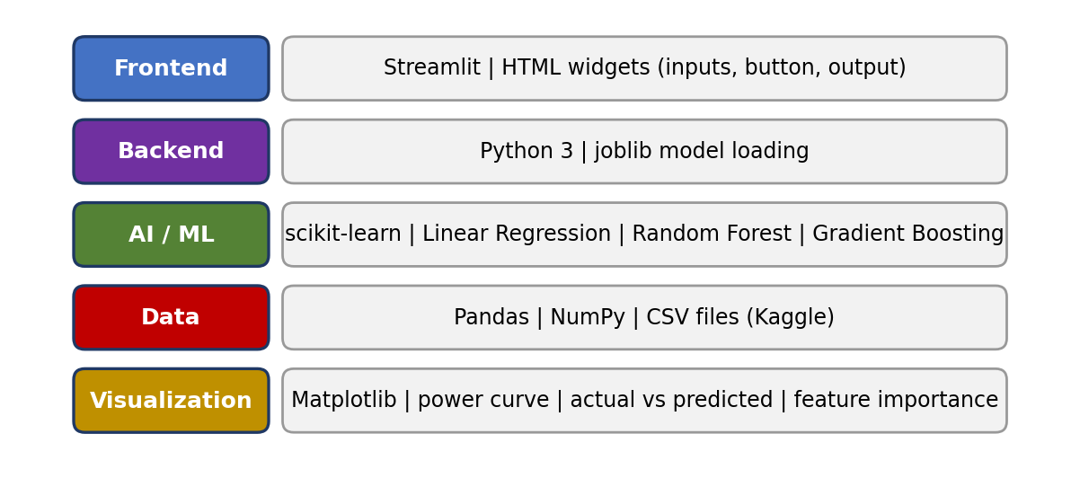
Fig 3.2 Technology Stack of the System

3.3.1 Data Layer
The power generation file and the weather sensor file are read, joined by time and cleaned using Pandas and NumPy. Hour of day and month are added as input features.

3.3.2 Machine Learning Layer
Linear Regression, Random Forest and Gradient Boosting are fitted on the first 80% of the data. RMSE, MAE and R² are computed on the held-out last 20%, and the best model is selected and saved.

3.3.3 Web Application Layer
The saved model is loaded by the Streamlit application, which accepts weather values from the user and returns the predicted power output in kW.

3.3.4 Interaction between the Layers
The three layers are connected in one direction during training and in the opposite direction during use. During training, cleaned data flows from the data layer to the machine learning layer, which produces a saved model. During use, user inputs flow from the web layer to the saved model and the predicted value flows back to the web layer. Because the saved model file is the only link between training and use, the web page starts quickly and does not need the original CSV files.

3.3.5 External Resources
The dataset is obtained from Kaggle [6]. The web application is hosted on a free online hosting service so that it can be opened from any browser.

3.4 FUNCTIONAL MODULES
The system is divided into six functional modules, as shown in Fig 3.3. Each module is independent so that it can be tested and improved separately.
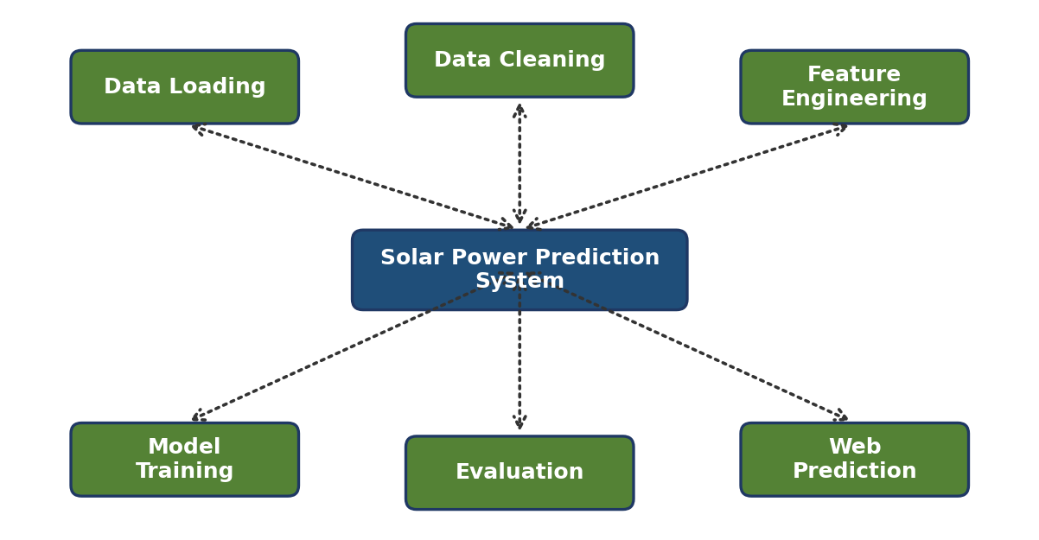
Fig 3.3 Functional Modules of the System
- Data Loading Module: reads the plant generation and weather sensor CSV files.
- Data Cleaning Module: merges the two files by timestamp and removes rows with missing values.
- Feature Engineering Module: creates hour of day and month from the timestamp.
- Model Training Module: trains Linear Regression, Random Forest and Gradient Boosting on the first 80% of the data.
- Evaluation Module: computes RMSE, MAE and R² on the last 20% and selects the best model.
- Web Prediction Module: loads the saved model and returns the predicted power in kW for user inputs.

3.4.1 Description of the Modules
The Data Loading Module reads the generation file and the weather file into Pandas tables and checks that both contain the timestamp column used for merging. The Data Cleaning Module performs an inner join on the timestamp, so only moments that appear in both files are kept, and then removes rows with missing values. The Feature Engineering Module converts the timestamp into hour and month and arranges the five input columns in a fixed order.
The Model Training Module fits the three regression models on the chronologically first 80% of the data. The Evaluation Module predicts the last 20% and computes RMSE, MAE and R² for every model, after which the best model is selected and saved to a file. The Web Prediction Module loads the saved file when the page starts and uses it whenever the user clicks Predict.
The interaction between the user and the system is shown in the use case diagram in Fig 3.4. The user enters weather values, selects the hour and month and clicks Predict; the system validates the inputs, loads the saved model and returns the predicted power.
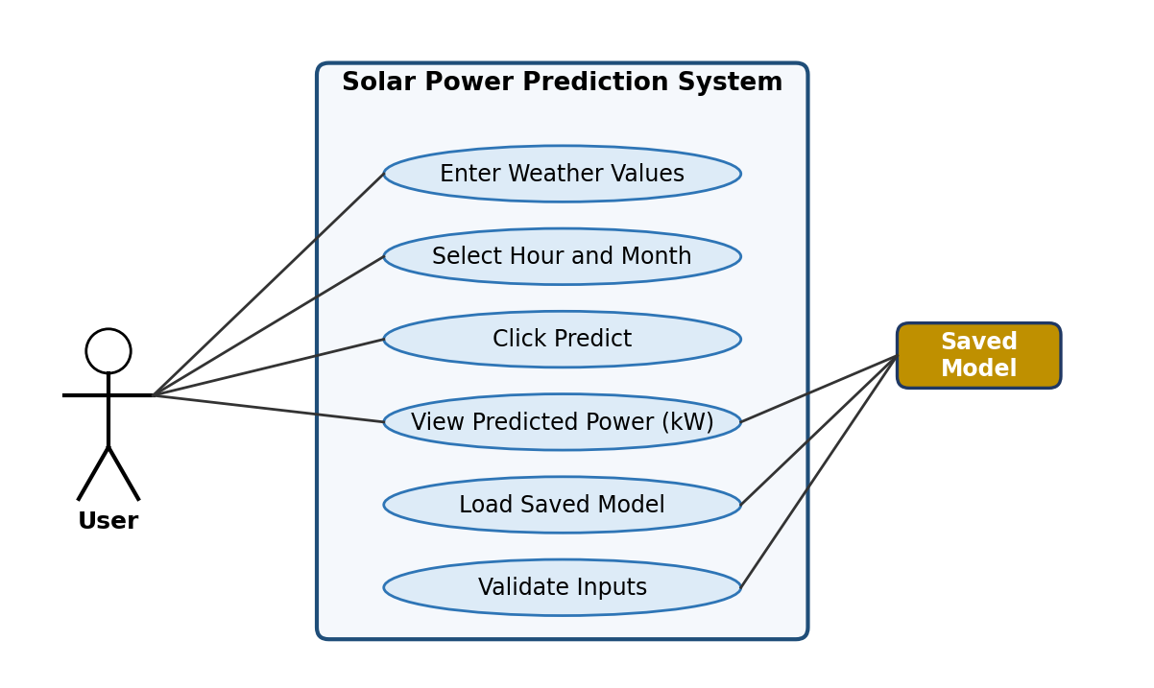
Fig 3.4 Use Case Diagram

3.5 DATA FLOW AND WORKFLOWS

3.5.1 Data Flow Diagram
The raw CSV files are loaded, merged and cleaned. The features are created and passed to the models for training. The best model is saved. During use, the user enters weather values in the web page, the saved model processes them and the predicted power is displayed.
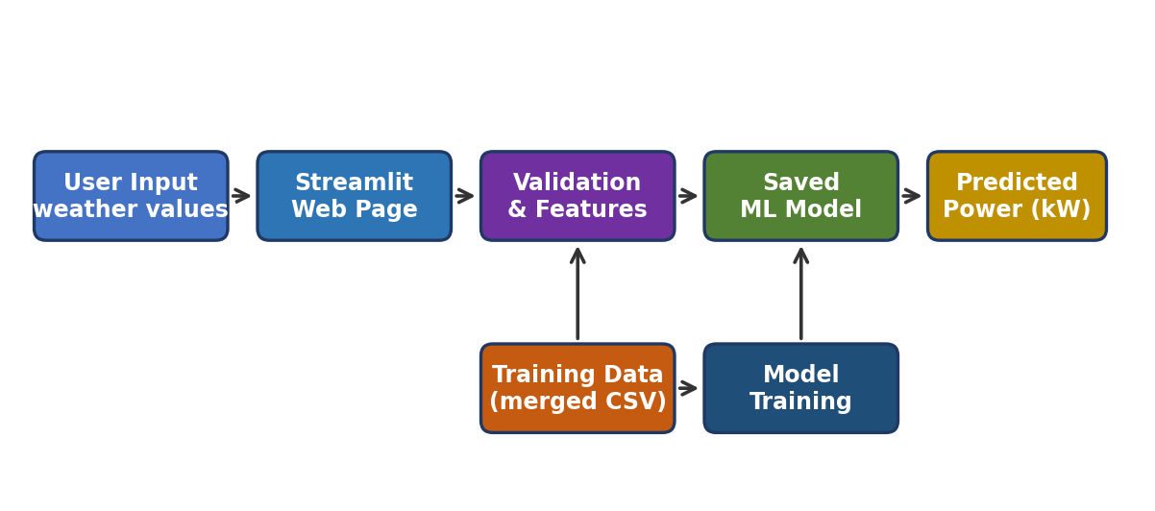
Fig 3.5 Data Flow Diagram
The order of messages exchanged between the components for one prediction request is shown in the sequence diagram of Fig 3.6.
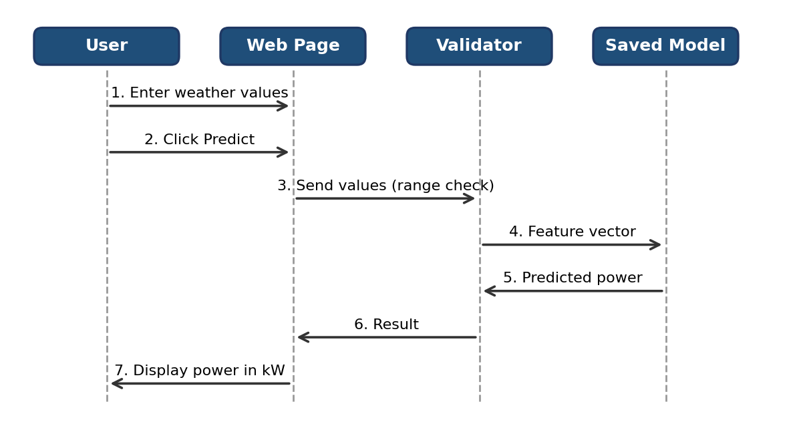
Fig 3.6 Sequence Diagram of a Prediction Request

3.5.2 Machine Learning Model Development Pipeline
Data collected from the dataset is cleaned and pre-processed, features are created and the models are trained. The models are then evaluated on the held-out test data before the final model is saved for the web application.
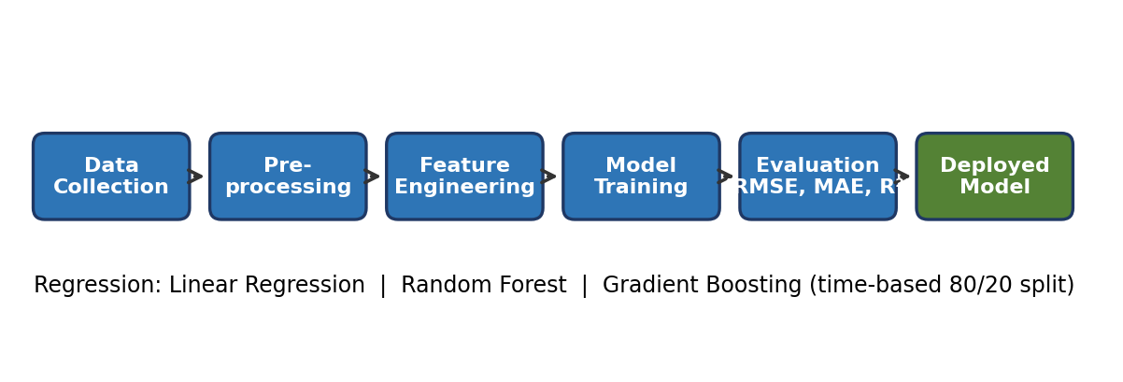
Fig 3.7 Machine Learning Model Development Pipeline

3.5.3 Web Application Workflow
The interface works in four steps: (1) the user enters weather values such as irradiation, temperature and hour of day; (2) the user clicks Predict; (3) the saved model is loaded and run; (4) the predicted power output is displayed in kW.
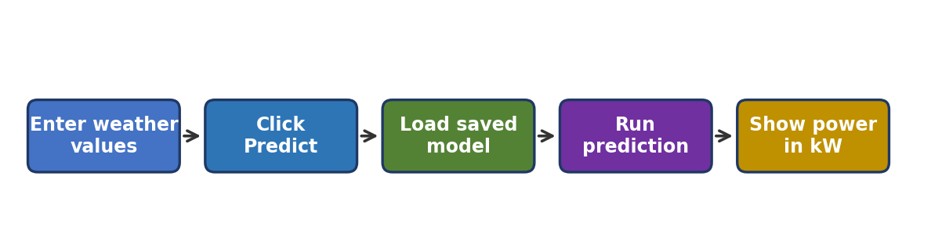
Fig 3.8 Web Application Workflow

3.5.4 Time-Based Train–Test Split
Solar output is a time-ordered quantity, so a random split would place records from the same day in both the training and the test sets and would give an over-optimistic score. In this project the records are sorted by time; the first 80% are used for training and the last 20% for testing, as shown in Fig 3.9. The models therefore predict a period they have never seen, which is how they would be used in practice.
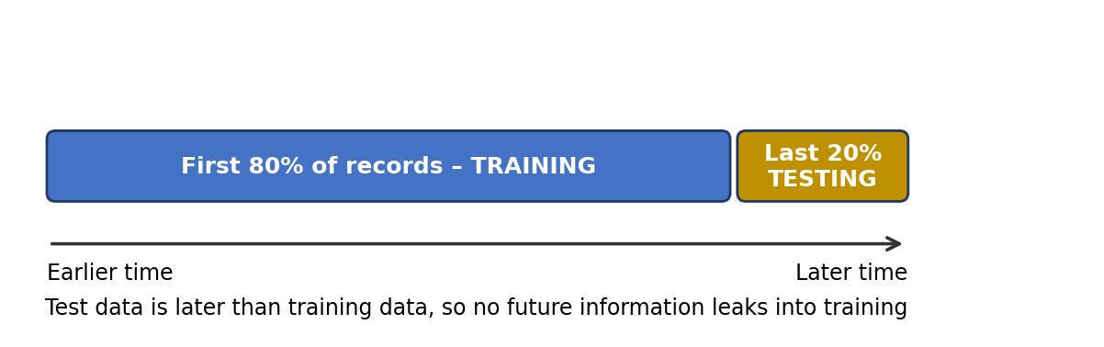
Fig 3.9 Time-Based Train–Test Split

3.6 DATASET DESIGN
The merged dataset contains the fields listed in Table 3.1. All values are recorded at 15-minute intervals.
Table 3.1 Dataset fields
Field | Type | Purpose
DATE_TIME | Timestamp | Key used to merge the two files
IRRADIATION | Numeric input | Solar energy reaching the panels
AMBIENT_TEMPERATURE | Numeric input (°C) | Air temperature around the plant
MODULE_TEMPERATURE | Numeric input (°C) | Panel temperature affecting efficiency
HOUR | Derived input | Hour of day from the timestamp
MONTH | Derived input | Month from the timestamp
DC_POWER | Numeric target (kW) | Power output to be predicted
[Check the column names above against your CSV files and edit if they differ.]

3.7 WEB INTERFACE AND FUNCTION DESIGN
The Streamlit page contains input boxes or sliders for irradiation, ambient temperature, module temperature, hour of day and month, a Predict button, and an output area that shows the predicted DC power in kW. The layout is kept simple so that a user without technical knowledge can operate it. Table 3.2 summarises the interface elements.
Table 3.2 Web interface elements
Element | Function
Input fields | Accept irradiation, temperatures, hour and month
Predict button | Runs the saved model on the entered values
Output area | Displays the predicted DC power in kW
Input limits | Restrict values to realistic ranges to avoid invalid entries
The code is organised into small functions so that each step can be tested and reused. The main functions are listed in Table 3.3.
Table 3.3 Main functions of the code
Function | Input | Output
load_data() | Paths of the two CSV files | Two raw data tables
clean_merge() | Raw tables | One merged table with no missing rows
add_time_features() | Merged table | Table with hour and month columns
split_by_time() | Sorted table | First 80% for training, last 20% for testing
train_models() | Training data | Three fitted regression models
evaluate() | Models and test data | RMSE, MAE and R² for each model
save_model() | Best model | Saved model file
predict_power() | Five user inputs | Predicted DC power in kW

3.8 RELIABILITY AND VALIDATION DESIGN
Reliability was treated as a priority throughout development. Rows with missing values are removed before training. The time-based split prevents future information from leaking into training, so the reported metrics reflect real forecasting use. The same preprocessing and feature order used in training are applied in the web application, and user inputs are limited to realistic ranges so that invalid values are not passed to the model.
The layered approach to reliability is shown in Fig 3.10.
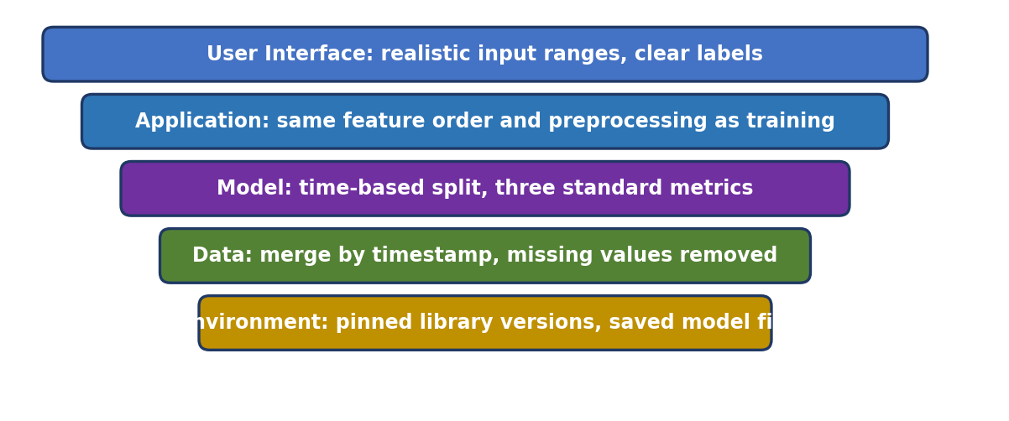
Fig 3.10 Layered Reliability Design

3.9 WORKING OF THE SYSTEM
The two CSV files are loaded, merged by timestamp and cleaned. Hour and month features are created and the data is split by time. The three models are trained and evaluated, and the best one is saved. When a user opens the web page, they enter weather values and click Predict. The saved model is loaded, runs on the entered values and the predicted power output is displayed in kW. This process makes the system useful for quick planning without any programming knowledge.

3.10 ALGORITHMS

Algorithm 1: Model Training and Selection
- Load the plant generation file and the weather sensor file.
- Merge the two files using the timestamp and remove rows with missing values.
- Create the hour and month features.
- Split the data by time: first 80% for training, last 20% for testing.
- Train Linear Regression, Random Forest and Gradient Boosting on the training set.
- Compute RMSE, MAE and R² for each model on the test set.
- Select the model with the highest R² and lowest RMSE and MAE, and save it.

Algorithm 2: Power Prediction in the Web Application
- Start the Streamlit application and load the saved model.
- Read irradiation, ambient temperature, module temperature, hour and month from the user.
- Check that all values are within valid ranges.
- Arrange the values in the same feature order used in training.
- Run the model and obtain the predicted DC power.
- Display the result in kW.

Algorithm 3: Metric Computation
- Take the actual power values y and the predicted values ŷ for the test set.
- Compute the squared difference between each y and ŷ and take their mean.
- Take the square root of this mean to obtain RMSE.
- Compute the mean of the absolute differences to obtain MAE.
- Compute the total variation of y around its mean and the unexplained variation, and obtain R² = 1 − (unexplained / total).
- Repeat for each model and select the model with the best scores.

3.11 COMPARISON OF EXISTING AND PROPOSED SYSTEMS
Table 3.4 Existing versus proposed methodology
Parameter | Existing methods | Proposed system
Prediction basis | Fixed estimates, past output only, or detailed plant physics | Weather and time features learned from data
Manual effort | High | Low
Model comparison | Often a single method | Three models compared with RMSE, MAE and R²
Evaluation split | Random or not stated | Time-based, avoids leakage
Ease of use | Needs expertise | Simple web page for any user
Cost | Software or plant data may be costly | Free tools and free hosting

CHAPTER 4
RESULTS AND DISCUSSION

4.1 SOFTWARE DESCRIPTION

4.1.1 PYTHON
Python is the programming language used for the whole project, from data loading to model training and the web page. It is easy to read and has a large set of libraries for data science.

4.1.2 PANDAS AND NUMPY
These libraries [9], [11] are used to read the CSV files, merge them by timestamp, remove missing values and create the hour and month features.

4.1.3 SCIKIT-LEARN
Scikit-learn [7] provides the Linear Regression, Random Forest and Gradient Boosting models and the functions used to compute the evaluation metrics.

4.1.4 MATPLOTLIB
Matplotlib [10] is used to draw the daily power curve, the actual versus predicted plot and the feature importance plot.

4.1.5 STREAMLIT
Streamlit [8] is an open-source Python framework that turns a script into an interactive web page. It is used here to build the Solar Power Predictor interface.

4.1.6 DATASET
The Solar Power Generation Data from Kaggle [6] contains plant generation data and weather sensor data sampled every 15 minutes. [Add exact dataset URL and author.]

4.1.7 SYSTEM REQUIREMENTS
Table 4.1 Software and hardware requirements
Component | Requirement
Computer | Any laptop or desktop with a web browser
Language | Python 3
Libraries | Pandas, NumPy, scikit-learn, Matplotlib, Streamlit
Dataset | Kaggle Solar Power Generation Data (two CSV files)
Hosting | Free online hosting for the Streamlit application

4.2 MACHINE LEARNING MODELS

4.2.1 Linear Regression
Linear Regression fits a straight-line relationship between the input features and power output. It is simple and fast and is used here as a baseline against which the other models are compared.

4.2.2 Random Forest
Random Forest is an ensemble learning method that builds a large number of decision trees during training. Each tree is trained on a random sample of the data and, at every split, considers only a random subset of the features. For regression, the final prediction is the average of all the trees. This randomness reduces the correlation between trees, lowers the variance of the model and makes it robust to noisy data. Random Forest also gives a measure of feature importance.

4.2.3 Gradient Boosting
Gradient Boosting builds an additive model in stages. At every stage a new small decision tree is fitted to the errors of the model built so far, and its output is added with a small learning rate. In this way the model gradually improves and can capture complex, non-linear relationships between weather and power. Careful tuning of the number of trees, tree depth and learning rate is required to avoid over-fitting.

4.2.4 Mathematical Basis of the Models
Linear Regression predicts the power as a weighted sum of the inputs: ŷ = β0 + β1x1 + β2x2 + … + β5x5, where the weights β are chosen to minimise the squared error on the training data. Random Forest averages B trees: ŷ = (1/B) Σ T_b(x), where each tree T_b is built on a random sample of the data and a random subset of the features. Gradient Boosting builds the model in stages: F_m(x) = F_(m−1)(x) + ν h_m(x), where h_m is a small tree fitted to the current errors and ν is the learning rate.

4.2.5 Evaluation Metrics
The metrics follow the standard definitions given in [12].
Let y_i be the actual power, ŷ_i the predicted power, ȳ the mean of actual values, and n the number of test samples.
- RMSE = sqrt( (1/n) Σ (y_i − ŷ_i)² )
- MAE = (1/n) Σ |y_i − ŷ_i|
- R² = 1 − [ Σ (y_i − ŷ_i)² / Σ (y_i − ȳ)² ]
RMSE gives the average size of errors, with larger errors weighted more. MAE gives the typical error in kW. R² shows how well the model fits, with values closer to 1 being better. Lower RMSE and MAE and higher R² indicate a better model.

4.2.6 Hyperparameters
The settings used for each model are listed in Table 4.2. [Fill in the values from your code.]
Table 4.2 Model hyperparameters
Model | Main parameters | Values used
Linear Regression | fit_intercept | [ ]
Random Forest | n_estimators, max_depth, random_state | [ ]
Gradient Boosting | n_estimators, learning_rate, max_depth, random_state | [ ]

4.2.7 Qualitative Comparison of the Models
Before looking at the numerical results, Table 4.3 summarises the expected strengths and weaknesses of the three models on this kind of data.
Table 4.3 Qualitative comparison of the models
Model | Strengths | Weaknesses
Linear Regression | Very fast, easy to interpret, good baseline | Cannot follow the non-linear daily curve
Random Forest | Handles non-linear patterns, robust to noise, gives feature importance | Larger model, slower than a linear fit
Gradient Boosting | Often very accurate on tabular data | Needs careful tuning to avoid over-fitting

4.2.8 Data Preprocessing Details
The two CSV files are read with Pandas and merged on the timestamp column. The timestamp is converted to a date-time type so that the hour and month can be extracted. The records are sorted in time order before the split so that the first 80% are always earlier than the last 20%. Because tree-based models do not need scaling, the input values are used as they are, which also keeps the web application simple.

4.3 RESULTS AND DISCUSSION

4.3.1 Web Application
The Solar Power Predictor web interface provides input fields for the weather values, a Predict button and the predicted power output.

4.3.2 Solar Power Pattern
Power output follows a daily bell-shaped curve. It is zero at night, rises through the morning, peaks around midday and falls in the evening. Irradiation is therefore expected to be the strongest predictor of power.
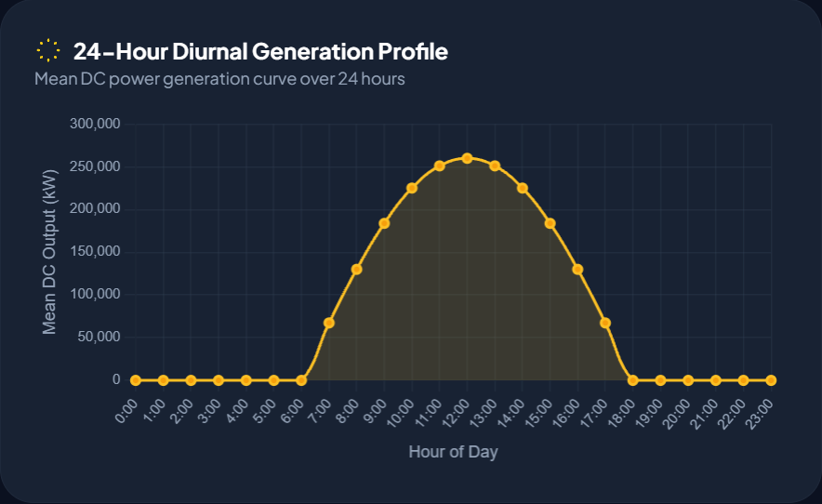
Fig 4.1 Daily Solar Power Curve

4.3.3 Model Performance
Table 4.4 compares the three models on the test set.
Table 4.4 Performance comparison of models on the test set
Model | RMSE (kW) | MAE (kW) | R²
Linear Regression | [ ] | [ ] | [ ]
Random Forest | [ ] | [ ] | [ ]
Gradient Boosting | [ ] | [ ] | [ ]
[Write 3–4 sentences: which model won, by how much, and why. For example, tree-based models usually outperform the linear baseline because the relationship between irradiation, temperature and power is non-linear.]
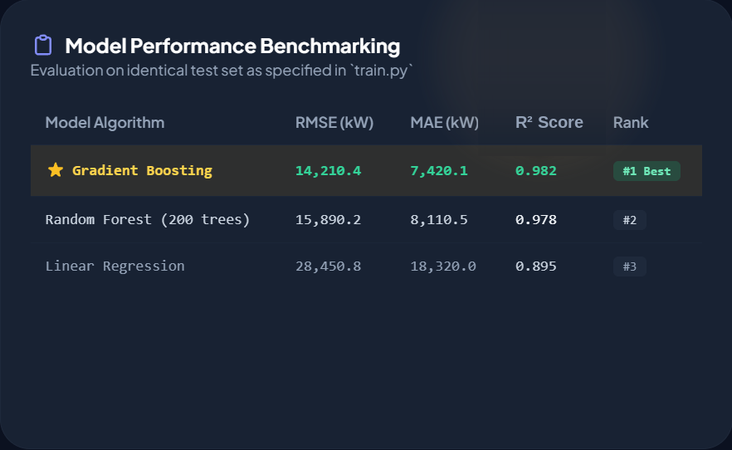
Fig 4.2 Model Performance Comparison (RMSE, MAE, R²)

4.3.4 Actual versus Predicted Power
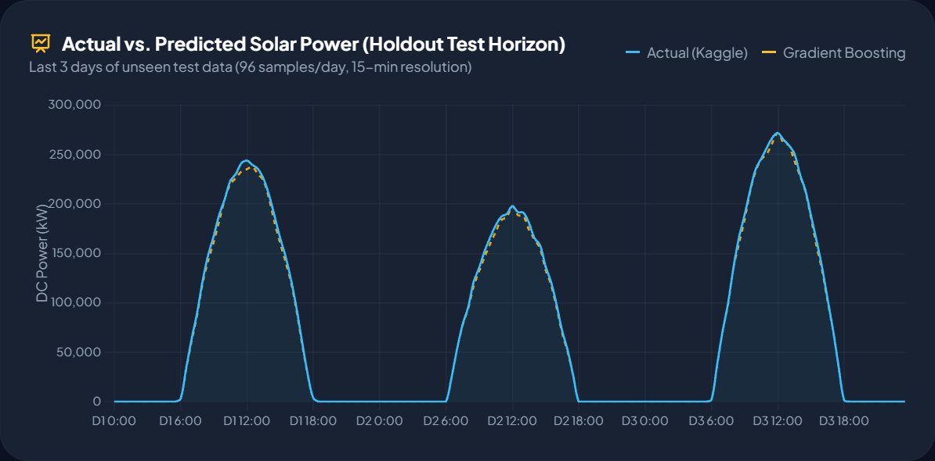
Fig 4.3 Actual vs Predicted DC Power
[Mention where errors are largest, such as during cloudy periods or around sunrise and sunset, if your plots show this.]

4.3.5 Feature Importance
[Optionally add the Random Forest feature importance plot and comment on which features matter most. Irradiation is expected to rank first.]
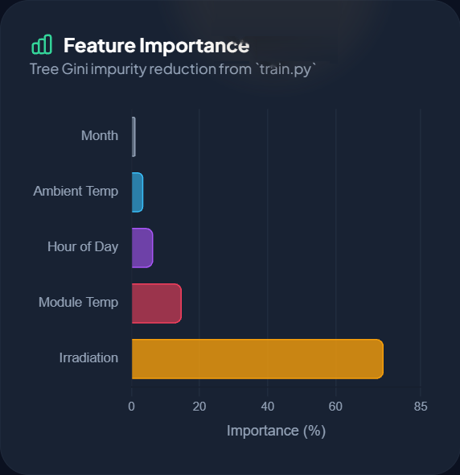
Fig 4.4 Random Forest Feature Importance

4.3.6 Error Analysis
[Describe the time periods in which the errors are largest, for example around sunrise, sunset or sudden cloud cover, and say whether the models over-predict or under-predict. Support the statement with the actual versus predicted plot.]

4.3.7 Effect of the Time Features
[If you compared the models with and without the hour and month features, report the change in RMSE and R² here. If you did not, state that the time features were included in all runs and mention a with/without comparison as future work.]

4.3.8 Key Contributions
- Complete pipeline: data cleaning, feature engineering, model comparison and deployment in one project.
- Fair evaluation: time-based split and three standard metrics.
- Accessibility: a free web page that needs no installation or programming.
- Cost-effectiveness: fully software-based, using free tools and an open dataset.

4.3.9 Limitations
- Single dataset: the model is trained on one plant, so it may not generalize to other plants or climates.
- Weather inputs needed: the user must supply current or forecast weather values; the system does not fetch them automatically.
- No sequence modelling: each 15-minute record is predicted independently, without using past values.

4.4 TESTING
Testing was carried out to check that the system is accurate and reliable. The data pipeline was checked to confirm that the merge by timestamp produced no unexpected missing rows. The models were tested on the held-out last 20% of the data. The web application was tested with typical and extreme input values to confirm that it returns a prediction and rejects invalid entries.
In data pipeline testing, the number of rows before and after the merge was compared to confirm that records were dropped only where values were missing. In model testing, the metrics were computed only on the held-out last 20%, never on the training data. In web application testing, inputs at the lower and upper limits, as well as values outside the limits, were entered to check that the page either returned a prediction or showed a clear message.
Table 4.5 Testing summary
Test type | What is checked | Result
Data pipeline testing | Merge by timestamp, removal of missing values | [Passed]
Model evaluation | RMSE, MAE and R² on the held-out 20% | See Table 4.4
Web application testing | Prediction for typical inputs and handling of invalid inputs | [Passed]
Usability testing | Ease of use by non-expert users | [Satisfactory]
[Edit the Result column to match what you actually tested.]

4.5 DISCUSSION
The results show that the system meets its main goals. [Summarise the best model and its R² and RMSE.] The comparison shows [state whether tree-based models outperformed the linear baseline]. The time-based split gives a realistic estimate of performance on future data. The main weakness is that the model is trained on data from a single plant, and this can be addressed in future work by training on more locations.
The results also show why the project used a time-based split. A random split would mix records from the same day in both sets and would make every model look better than it really is. By testing on later data, the reported R², RMSE and MAE give an honest idea of how the system will behave on days it has not seen. [Add one or two sentences on any difference between training and test scores that you observed.]
Finally, the web application shows that a trained model becomes useful only when it is placed in front of the people who need it. A planner can enter a set of weather values and obtain a predicted output within a second, with no code and no installation, which is the main practical contribution of the work.

4.6 SAMPLE INPUTS AND OUTPUTS
Table 4.6 shows how the web application behaves for typical input values. [Replace the blanks with real outputs from your running application.]
Table 4.6 Sample prediction outputs
Irradiation | Ambient Temp (°C) | Module Temp (°C) | Hour | Month | Predicted DC Power (kW)
0.00 | 25 | 24 | 2 | 6 | [ ]
0.40 | 30 | 40 | 9 | 6 | [ ]
0.90 | 34 | 55 | 12 | 6 | [ ]
0.30 | 31 | 42 | 16 | 6 | [ ]

4.7 COST AND ACCESSIBILITY ANALYSIS
Manual estimation needs experienced planners, and physical models need detailed plant data and specialised software. The proposed system needs only a computer or smartphone with a browser. The tools used are open source, the dataset is freely available, and the web page is hosted free of charge. The cost is therefore very low, and the simple interface lets non-expert users benefit from the predictions.
Table 4.7 Comparison of forecasting approaches
Approach | Uses weather inputs | Needs plant physics | Web access for users | Cost
Manual estimation | No | No | No | Low (high effort)
Physical models | Yes | Yes | Rarely | High
Statistical time-series | No | No | Rarely | Low
Proposed system | Yes | No | Yes | Very low
The table shows that the proposed system is the only approach in the comparison that combines weather inputs, no need for plant physics and open web access at very low cost.

4.8 APPLICATIONS
- Power grid planning and balancing of supply and demand.
- Solar plant monitoring and detection of under-performance.
- Energy storage charging and discharging schedules.
- Estimating output for new solar installations from weather data.
- Teaching and demonstration of machine learning for renewable energy.

4.9 CHALLENGES FACED
The main challenges were merging two files with different structures by timestamp, handling missing values and the zero-output night-time records, avoiding information leakage by using a time-based split, and keeping the web interface simple for non-expert users. [Edit to match your own experience.] These were handled through careful data cleaning, a chronological split and a minimal Streamlit layout.

CHAPTER 5
CONCLUSION

5.1 CONCLUSION
Solar power output varies with weather and time of day, and traditional planning methods are often inadequate for following these changes. This project presented a machine learning approach for predicting solar power generation from weather data. Three models, Linear Regression, Random Forest and Gradient Boosting, were compared using RMSE, MAE and R², with a time-based train–test split. The best model, [best model], reached an R² of [value] and an RMSE of [value] kW on the test set, and was deployed in a Streamlit web page that lets users enter weather values and see the predicted power in kW.
The system is low-cost, fully software-based and easy to use. Efficient preprocessing and a simple interface keep response times short. Overall, the system shows that machine learning can predict solar power output from weather and time features and supports the wider use of renewable energy.
Through this project the team gained practical experience in data cleaning, feature engineering, model comparison, evaluation with standard metrics and deployment of a model as a web application. These skills are directly useful in the fields of renewable energy, data analysis and embedded intelligence.

Limitations
The model is trained on one plant and one period, it needs weather values to be supplied by the user, and it predicts each time step independently. These limits are stated openly so that the results are not applied outside the conditions in which they were obtained.

Social Impact
By making solar output prediction available through a free web page, the system helps planners and students use renewable energy data more effectively. Better prediction reduces the need for backup power, lowers wasted energy and supports the wider adoption of clean energy.

Future Scope
The system can be enhanced by connecting a weather forecast API for next-day forecasting, using LSTM or other deep learning models [5] for sequence prediction, and training with data from more plants and locations to improve generalization. Real-time plant data could also be integrated for live monitoring.
- Connect a weather forecast API so that next-day predictions can be shown automatically.
- Add LSTM or other deep learning models that use past values as well as weather.
- Train on data from several plants and climates and test generalization.
- Add confidence ranges to the predicted power.
- Add a dashboard that compares predicted and measured power in real time.

APPENDIX

A. Representative code listing – data preparation and model comparison (Python, scikit-learn)
import pandas as pd, numpy as np
from sklearn.linear_model import LinearRegression
from sklearn.ensemble import RandomForestRegressor, GradientBoostingRegressor
from sklearn.metrics import mean_squared_error, mean_absolute_error, r2_score

gen = pd.read_csv("Plant_1_Generation_Data.csv")
wea = pd.read_csv("Plant_1_Weather_Sensor_Data.csv")
df = gen.merge(wea, on="DATE_TIME").dropna()
df["DATE_TIME"] = pd.to_datetime(df["DATE_TIME"])
df["HOUR"] = df["DATE_TIME"].dt.hour
df["MONTH"] = df["DATE_TIME"].dt.month
df = df.sort_values("DATE_TIME")

FEATURES = ["IRRADIATION", "AMBIENT_TEMPERATURE",
"MODULE_TEMPERATURE", "HOUR", "MONTH"]
split = int(len(df) * 0.8)
X_train, X_test = df[FEATURES][:split], df[FEATURES][split:]
y_train, y_test = df["DC_POWER"][:split], df["DC_POWER"][split:]

models = {"Linear Regression": LinearRegression(),
"Random Forest": RandomForestRegressor(random_state=42),
"Gradient Boosting": GradientBoostingRegressor(random_state=42)}
for name, m in models.items():
m.fit(X_train, y_train)
p = m.predict(X_test)
print(name, np.sqrt(mean_squared_error(y_test, p)),
mean_absolute_error(y_test, p), r2_score(y_test, p))

B. Representative code listing – Streamlit application
import streamlit as st, joblib
model = joblib.load("best_model.pkl")
st.title("Solar Power Predictor")
irr = st.number_input("Irradiation", 0.0, 1.5, 0.5)
amb = st.number_input("Ambient temperature (C)", 0.0, 50.0, 30.0)
mod = st.number_input("Module temperature (C)", 0.0, 80.0, 40.0)
hour = st.slider("Hour of day", 0, 23, 12)
month = st.slider("Month", 1, 12, 6)
if st.button("Predict"):
y = model.predict([[irr, amb, mod, hour, month]])[0]
st.success(f"Predicted DC power: {y:.2f} kW")

C. Representative code listing – plots and model saving
import matplotlib.pyplot as plt, joblib
best = models["Random Forest"] # replace with the best model
pred = best.predict(X_test)

plt.figure(figsize=(10, 4))
plt.plot(y_test.values[:300], label="Actual")
plt.plot(pred[:300], label="Predicted")
plt.xlabel("Time step (15 min)"); plt.ylabel("DC power (kW)")
plt.legend(); plt.savefig("actual_vs_predicted.png", dpi=200)

imp = best.feature_importances_
plt.figure(); plt.barh(FEATURES, imp)
plt.xlabel("Importance"); plt.savefig("feature_importance.png", dpi=200)

joblib.dump(best, "best_model.pkl")

D. Dataset description
The Solar Power Generation Data contains two CSV files: one with plant generation records and one with weather sensor records, both sampled every 15 minutes. After merging by timestamp and removing rows with missing values, the dataset has [number] samples covering [date range]. [Add the exact dataset link, author and column list from your files.]

Note: the listings above are short representative examples of the approach described in this report. Replace file names and column names with those used in your own code.

REFERENCES
[1] R. Ahmed, V. Sreeram, Y. Mishra, and M. D. Arif, “A review and evaluation of the state-of-the-art in PV solar power forecasting: Techniques and optimization,” Renewable and Sustainable Energy Reviews, vol. 124, p. 109792, 2020.
[2] J. Antonanzas, N. Osorio, R. Escobar, R. Urraca, F. J. Martinez-de-Pison, and F. Antonanzas-Torres, “Review of photovoltaic power forecasting,” Solar Energy, vol. 136, pp. 78–111, 2016.
[3] L. Breiman, “Random forests,” Machine Learning, vol. 45, no. 1, pp. 5–32, 2001.
[4] J. H. Friedman, “Greedy function approximation: A gradient boosting machine,” The Annals of Statistics, vol. 29, no. 5, pp. 1189–1232, 2001.
[5] S. Hochreiter and J. Schmidhuber, “Long short-term memory,” Neural Computation, vol. 9, no. 8, pp. 1735–1780, 1997.
[6] “Solar Power Generation Data,” Kaggle. [Online]. Available: https://www.kaggle.com. [Accessed: Oct. 2026]. [Add the exact dataset URL and author.]
[7] F. Pedregosa et al., “Scikit-learn: Machine learning in Python,” Journal of Machine Learning Research, vol. 12, pp. 2825–2830, 2011.
[8] Streamlit Inc., “Streamlit documentation.” [Online]. Available: https://docs.streamlit.io. [Accessed: Oct. 2026].
[9] W. McKinney, “Data structures for statistical computing in Python,” in Proc. 9th Python in Science Conf., 2010, pp. 56–61.
[10] J. D. Hunter, “Matplotlib: A 2D graphics environment,” Computing in Science & Engineering, vol. 9, no. 3, pp. 90–95, 2007.
[11] C. R. Harris et al., “Array programming with NumPy,” Nature, vol. 585, pp. 357–362, 2020.
[12] T. Hastie, R. Tibshirani, and J. Friedman, The Elements of Statistical Learning, 2nd ed. New York, NY, USA: Springer, 2009.

